9.10

Detailed fills:

1. IOC and cancelled:

Constructed -> pending cancel (IOC order)

1. Day and filled

Constructed -> presubmitted -> submitted -> filled

1. IOC and filled

Constructed-> presubmitted -> filled

Start coding new strat

Strat 1

Fut tick data 2 MA trader

1. 2 MA: 100/200 (arbitrary)
2. Should compute MA such that trading points is under n.

Strat2

Fut tick data inventory trader

1. 2 MA
2. Above, keep accumulating on lows and distribute on highs
3. Below, keep selling on highs and cover on lows.

Strat 3.

Fut accumulation trader

1. Accumulating when MA is upward sloping, decumulate when MA is downward sloping

Strat 4.

New high and new Lo deviation trader (with loss cutting)

1. Set newhigh/newlow as the bench
2. Increase position on further evidence
3. Cut position on touching the same level.

Strat 5:

When market moves fast in 1 direction, take advantage of the high frequency opportunity

1. Identify when the market is moving, through various measure
2. follow

Strat 6:

1. Identify

Today trading pnl is positive, which is good, but clearly there lacks something.

Day end:

net pnl 5.95 breakdown:

||| INDEX_HILO #: 2 Tot Q: -2.0 195.97,

||| INDEX_PM_HILO #: 3 Tot Q: -4.0 -20.1,

||| INTRADAY_MA #: 2 Tot Q: 3.0 -42.01,

||| FUT_HILO #: 3 Tot Q: -1.0 -50.02,

||| FUT_OPEN_DEVI #: 1 Tot Q: 2.0 -103.01 ( can only when in discount, not reliable, reduce size to 1 each)

**Changes**

1. Index pmopen deviation -> change TIF to DAY, lmt stay passive
2. Index hilo base size + 1, performance was good because
3. Fut_open_devi, reduce to 1 size each.
4. No strict fills -> even if last dev order was not filled (mostly due to IOC)
5. Sizing on no strict fill -> equal size on long/short

**Improvements:**

1. Create a high frequency trader

9.13

Bugs

1. Guarantee fills were increasing order size of original trade type, so changing order type to force_fill
2. All strategies start at 9:30, not 9:00
3. Pre 9:30 strategies have no edge. Delay everything to 9:30.
4. Trade pnl -85 so far before open, pointless.
5. Fut open trader + fut open deviation trader suspended (no profit during 9:00-9:30 period)
6. Forced fill is losing money due to

Not even 1 strategy is making money, this shows that there are issues.

1. Futhilo and futopendev suspended (no profit opportunity at open, prices are random). Keep
2. Index open dev -> change to default order handler (don’t want to suffer bid/ask spread at the open) there is possibility can’t be filled.
3. Indexhilo -> change to guaranteeFill, fixed bug (stuck when last order != filled (even when pending cancel)). Index hilo is must fill.
4. Want strategies that are scalable.

Deviation – day, defaultOrderhandler

Hilo – IOC, GuaranteedOrderhandler

**9.14**

Weekly review:

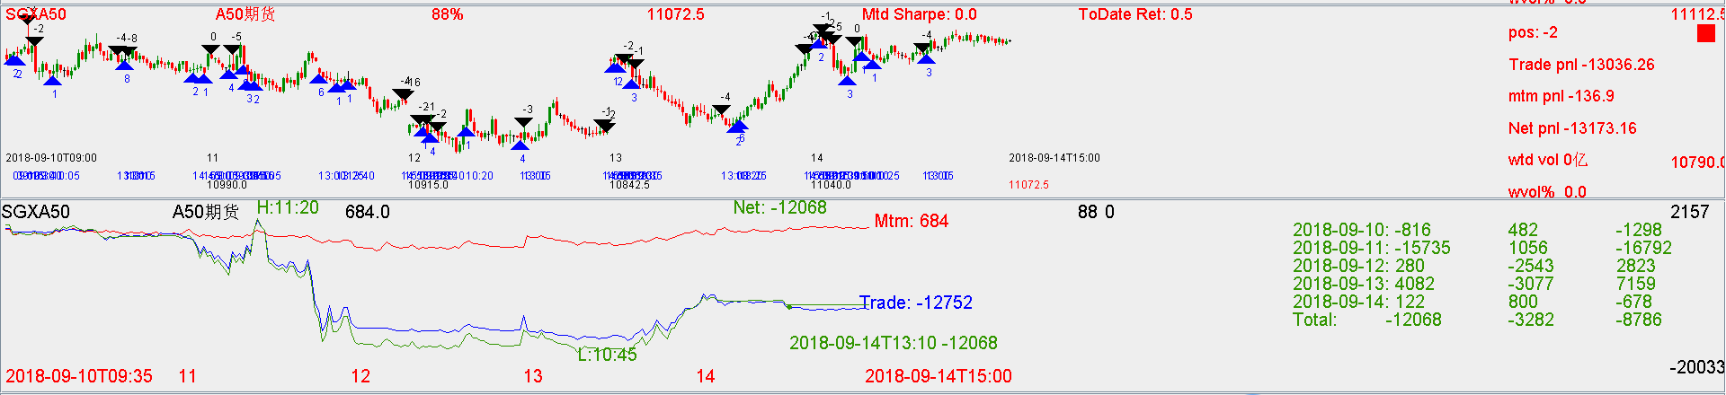

Pnl: -10k.

Monday: not much action

Tues: -15k, PM crashed but didn’t trade, (bug was due to all forcedfills counting towards order

limit-> forced fills should not count towards upper limit)

Wed:

Thur: made money (pm hilo sharpe is high)

Fri: Opening trading was good, intradayMA cover at 10 is good.

This week improvements:

1. Guarantee fills of hilo IOC orders. Default fills of DAY orders.
2. Max trade of 4 per strategy
3. Fri afternoon pmhilo, looking at time diff between last two and decide the wait time is useful
4. Pnl counting is not good because forced fill is listed separately now. It still needs to count towards the strategy pnl, but it cannot count towards the limit.
5. Fut types only until 9:30, index types until 10. PM types from 13 to 14 to avoid overtrading.

Prospect next week:

1. Start to trade hilo and deviation on volatile stocks
2. Start with all volatile US stocks and HK (china concept stocks)